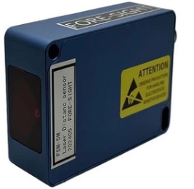

Developed for industrial applications, they are used to avoid collisions, measure the level of liquids and solids, profile conveyor belts, detect proximity, position and monitor equipment, or even altimetry applications. Variation in material characteristics or difference in environmental conditions can be a contributing factor to a particular sensor not functioning properly.
LDS lasers are class I are low power lasers (< 1 mW), visible light are absolutely safe for the eyes and skin

Measurable objects: , surfaces of natural objects, metallic non-reflective, wood, plastic, coal,
Non-measurable: mirrors and transparent objects
Environmental Limitations Surfaces with very high direct sunlight
Resolution 0.1mm
Ripetibilita ±0.3mm（5m），±0.5mm（20m），±0.8mm（50m）
Response time 100ms
Laser Type 640nm red laser, Class 1
Tipi di misura Power on automatic measurement/command measurement
Consume < 1W
Impedance ≤500Ω
Input voltage 6-32VDC
Communication mode 485,232
Working temperature -25℃--65℃
Dimensions 60mm x 61mm x 30mm 150g
IP IP68 Grade

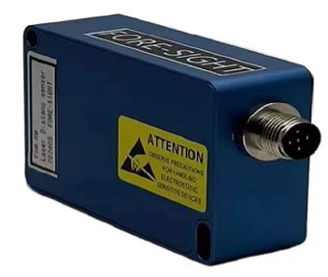

Error value specification
Code Fault cause solution
03 The temperature is too low warming
07 Incident light intensity Reduced incident light influence
04 Temperature is too high hypothermia
08 Signal is too weak The reflector is not enough, please use the reflector
09 Signal is too strong Reduce the reflection of the object under test
15 Vibrate too fast Reduce the vibration of the measured object
18 Too close Increase measuring distance

19 Out of range Things move too fast Reduce measuring distance
Reduce the movement speed of the measured object
